**Chapter 5**

**Lab 5.1 insert_select**

**1.Write a C# program to show insert and select student record with given table (tblStudent) with fields (int id, nvarchar(50) name, nvarchar(50) address, nvarchar(50) gender). Also display total no of student from table.**

**Creating table:**

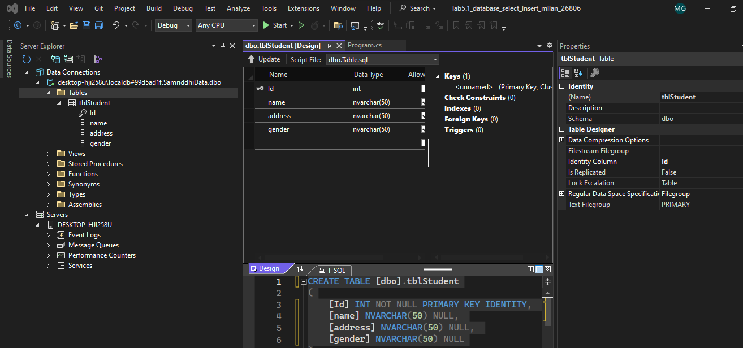

using System;

using System.Collections.Generic;

using System.Data.SqlClient;

using System.Data;

using System.Linq;

using System.Text;

using System.Threading.Tasks;

namespace lab5._1_database_select_insert_milan_26806

{

internal class Program

{

static void Main(string[] args)

{

StudentInsert_Select obj = new StudentInsert_Select();

for (int i = 0; i < 2; i++)

{

Console.WriteLine("Enter Student:" + (i + 1));

Console.Write("Enter Name:");

string name = Console.ReadLine();

Console.Write("Enter Address:");

string address = Console.ReadLine();

Console.Write("Enter Gender:");

string gender = Console.ReadLine();

obj.Insert(name, address, gender);

Console.WriteLine("Record Inserted");

}

Console.WriteLine();

Console.WriteLine("*********************");

Console.WriteLine("All Student");

DataTable dt = obj.GetAllStudent();

for (int i = 0; i < dt.Rows.Count; i++)

{

string name = dt.Rows[i]["Name"].ToString();

string address = dt.Rows[i]["Address"].ToString();

string gender = dt.Rows[i]["Gender"].ToString();

Console.WriteLine("Name:{0} Address:{1} Gender:{2}", name, address, gender);

}

Console.WriteLine("*******************");

Console.WriteLine("Total No of Student: " + dt.Rows.Count);

Console.ReadLine();

}

}

public class StudentInsert_Select

{

public void Insert(string name, string address, string gender)

{

string connStr = @"Data Source=(localdb)\MSSqlLocalDB; Database=SamriddhiData; Integrated Security=true";

SqlConnection con = new SqlConnection(connStr);

string sql = "insert into tblStudent values(@name,@address,@gender)";

SqlCommand cmd = new SqlCommand(sql, con);

cmd.Parameters.AddWithValue("@name", name);

cmd.Parameters.AddWithValue("@address", address);

cmd.Parameters.AddWithValue("@gender", gender);

con.Open();

cmd.ExecuteReader();

con.Close();

}

public DataTable GetAllStudent()

{

string connStr = @"Data Source=(localdb)\MSSqlLocalDB; Database=SamriddhiData; Integrated Security=true";

SqlConnection con = new SqlConnection(connStr);

string sql = "select *from tblStudent";

SqlCommand cmd = new SqlCommand(sql, con);

SqlDataAdapter da = new SqlDataAdapter(cmd);

DataTable dt = new DataTable();//can hold data in tabular format

da.Fill(dt);

return dt;

}

}

}

Output

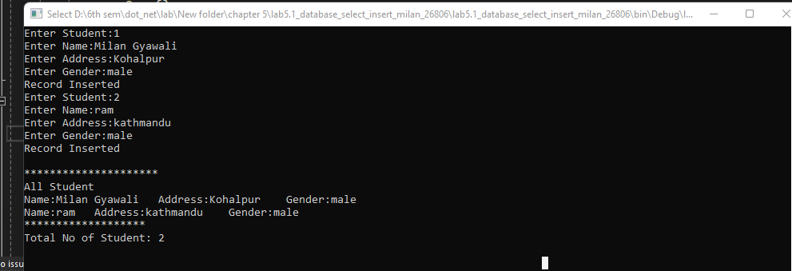

Table data:

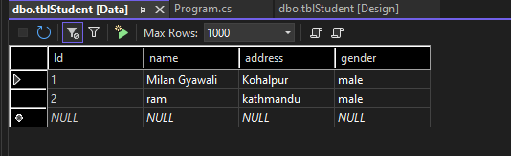

Path :

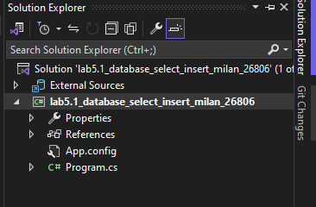

**Lab 5.2 insert fetch**

**2.Write a C# program to show insert and fetch student record by Gender from given table (tblStudent) with fields (int id, nvarchar(50) name, int age, nvarchar(50) gender).**

using System;

using System.Collections.Generic;

using System.Data.SqlClient;

using System.Data;

using System.Linq;

using System.Text;

using System.Threading.Tasks;

namespace lab5._2_database_milan_26806

{

internal class Program

{

static void Main(string[] args)

{

StudentInsert_SelectRecord obj = new StudentInsert_SelectRecord();

Console.Write("Enter Name:");

string name = Console.ReadLine();

Console.Write("Enter Address:");

string address = Console.ReadLine();

Console.Write("Enter Gender:");

string gender = Console.ReadLine();

obj.Insert(name, address, gender);

Console.WriteLine("Record Inserted");

Console.WriteLine();

Console.WriteLine("*********************");

Console.WriteLine("All Student By Gender");

DataTable dt = obj.GetAllStudentByGender("Male");

for (int i = 0; i < dt.Rows.Count; i++)

{

string n = dt.Rows[i]["Name"].ToString();

string a = dt.Rows[i]["Address"].ToString();

string g = dt.Rows[i]["Gender"].ToString();

Console.WriteLine("Name:{0} Address:{1} Gender:{2}", name, address, gender);

}

Console.WriteLine("*******************");

Console.WriteLine("Total No of Student: " + dt.Rows.Count);

Console.ReadLine();

}

}

public class StudentInsert_SelectRecord

{

public void Insert(string name, string address, string gender)

{

string connStr = @"Data Source=(localdb)\MSSqlLocalDB; Database=SamriddhiData; Integrated Security=true";

SqlConnection con = new SqlConnection(connStr);

string sql = "insert into tblStudent values(@name,@address,@gender)";

SqlCommand cmd = new SqlCommand(sql, con);

cmd.Parameters.AddWithValue("@name", name);

cmd.Parameters.AddWithValue("@address", address);

cmd.Parameters.AddWithValue("@gender", gender);

con.Open();

cmd.ExecuteReader();

con.Close();

}

public DataTable GetAllStudentByGender(string gender)

{

string connStr = @"Data Source=(localdb)\MSSqlLocalDB; Database=SamriddhiData; Integrated Security=true";

SqlConnection con = new SqlConnection(connStr);

string sql = "select *from tblStudent where Gender=@gender";

SqlCommand cmd = new SqlCommand(sql, con);

cmd.Parameters.AddWithValue("@gender", gender);

SqlDataAdapter da = new SqlDataAdapter(cmd);

DataTable dt = new DataTable();//can hold data in tabular format

da.Fill(dt);

return dt;

}

}

}

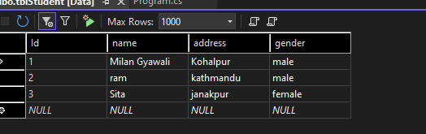

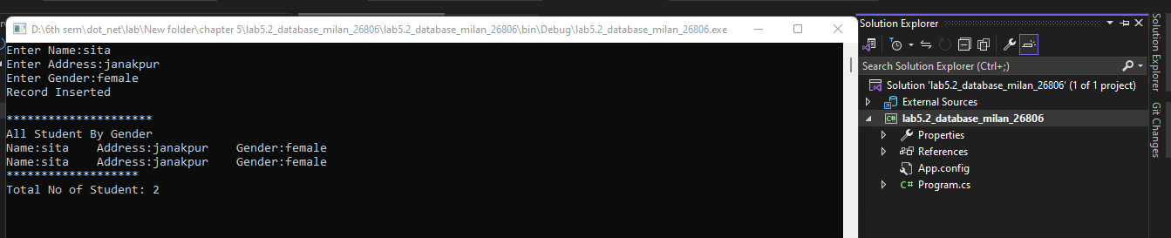

Lab 5.3 Insert _ update _ delete _fetch

**Write a C# program to perform (CRUD) Operation from given table (tblStudent) with fields (int id, nvarchar(50) name, int age, nvarchar(50) gender).**

using System;

using System.Collections.Generic;

using System.Data.SqlClient;

using System.Data;

using System.Linq;

using System.Text;

using System.Threading.Tasks;

namespace lab5._3_database_milan_26806

{

internal class Program

{

static void Main(string[] args)

{

Student st = new Student();

Console.WriteLine("Enter Option");

Console.WriteLine("1 For Insert Student");

Console.WriteLine("2 For Update Student");

Console.WriteLine("3 For Delete Student");

Console.WriteLine("4 For Fetch All Student");

string option = Console.ReadLine();

switch (option)

{

case "1":

Console.Write("Enter Name: ");

string name = Console.ReadLine();

Console.Write("Enter Address: ");

string address = Console.ReadLine();

Console.Write("Enter Gender: ");

string gender = Console.ReadLine();

st.InsertStudent(name, address, gender);

Console.WriteLine("Record Inserted");

break;

case "2":

Console.Write("Enter Id To Update: ");

int id = Convert.ToInt32(Console.ReadLine());

Console.Write("Enter Name: ");

string uname = Console.ReadLine();

Console.Write("Enter Address: ");

string uaddress = Console.ReadLine();

Console.Write("Enter Gender: ");

string ugender = Console.ReadLine();

st.UpdateStudent(uname, uaddress, ugender, id);

Console.WriteLine("Record Updated");

break;

case "3":

Console.Write("Enter Id To Update: ");

int did = Convert.ToInt32(Console.ReadLine());

st.DeleteStudent(did);

Console.WriteLine("Record Deleted");

break;

case "4":

DataTable dt = st.DisplayStudentData();

for (int i = 0; i < dt.Rows.Count; i++)

{

Console.WriteLine("Name:{0} Address:{1} Gender:{2}",

dt.Rows[i]["Name"], dt.Rows[i]["Address"], dt.Rows[i]["Gender"]);

}

break;

default:

break;

}

Console.ReadLine();

}

}

public class Student

{

public void InsertStudent(string name, string address, string gender)

{

string connStr = @"Data Source=(localdb)\MSSqlLocalDB; Database=SamriddhiData; Integrated Security=true";

SqlConnection con = new SqlConnection(connStr);

string sql = "insert into tblStudent values(@name,@address,@gender)";

SqlCommand cmd = new SqlCommand(sql, con);

cmd.Parameters.AddWithValue("@name", name);

cmd.Parameters.AddWithValue("@address", address);

cmd.Parameters.AddWithValue("@gender", gender);

con.Open();

cmd.ExecuteNonQuery();

con.Close();

}

public void UpdateStudent(string name, string address, string gender, int id)

{

string connStr = @"Data Source=(localdb)\MSSqlLocalDB; Database=SamriddhiData; Integrated Security=true";

SqlConnection con = new SqlConnection(connStr);

string sql = "update tblStudent set Name=@name, Address=@address, Gender=@gender where Id=@id";

SqlCommand cmd = new SqlCommand(sql, con);

cmd.Parameters.AddWithValue("@name", name);

cmd.Parameters.AddWithValue("@address", address);

cmd.Parameters.AddWithValue("@gender", gender);

cmd.Parameters.AddWithValue("@id", id);

con.Open();

cmd.ExecuteNonQuery();

con.Close();

}

public void DeleteStudent(int id)

{

string connStr = @"Data Source=(localdb)\MSSqlLocalDB; Database=SamriddhiData; Integrated Security=true";

SqlConnection con = new SqlConnection(connStr);

string sql = "delete from tblStudent whwere Id=@id";

SqlCommand cmd = new SqlCommand(sql, con);

cmd.Parameters.AddWithValue("@id", id);

con.Open();

cmd.ExecuteNonQuery();

con.Close();

}

public DataTable DisplayStudentData()

{

string conStr = "Data Source=(LocalDB)\\MSSQLLocalDB; Database=SamriddhiData; Integrated Security=true";

SqlConnection con = new SqlConnection(conStr);//

SqlCommand cmd = new SqlCommand("select *from tblStudent", con);

SqlDataAdapter da = new SqlDataAdapter(cmd);//works as mediator between datasource=datatable

DataTable dt = new DataTable();//row column

da.Fill(dt);

return dt;

}

}

}

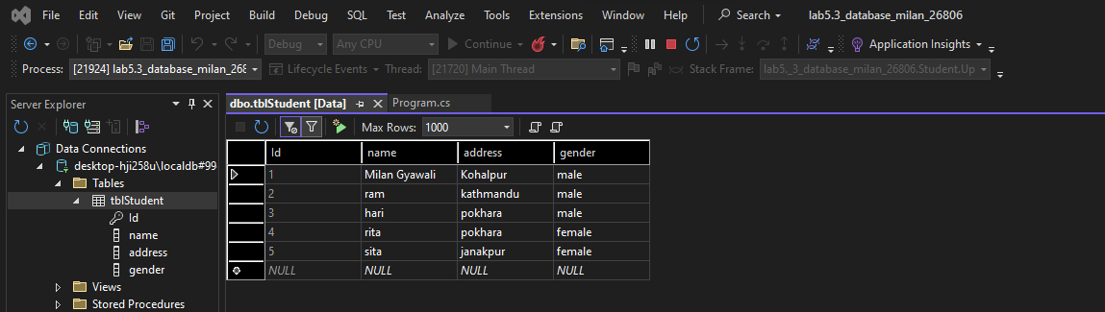

Inserted

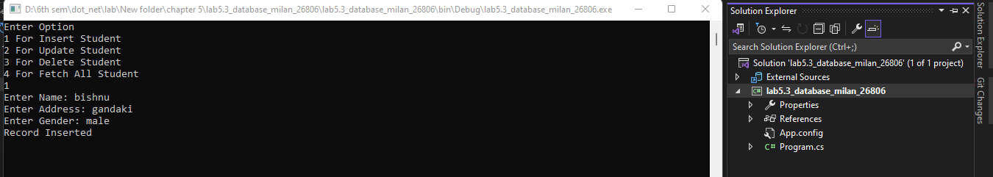

Deleted

